Traveller 5

Vland

maggot.iiss@sky.com

Subsector guide

General Details for Imperial Forces

M Parsi

R U Ready 4 WAR? - Indispensable Notebook
Imperial Naval Intelligence for Travellers.
5FW style System box.
T4 Imperial Squadrons & Commodores.
T4 Pocket Empires Troops.
T5 System maps.
Links to relevant data online.
Collated into a PDF with 1 System per sheet of print
Does not contain rules:
but 5FW, IE, IS, PE, MgT or any other should work.

maggot.iiss@sky.com

Saarpuhii
Engegueklii Agushdakemgam (Call me Klii)
Duke of Kesali (Vland/2737)
Co Starring - Walter the Wobot!
(with a lithp - Dukes' Butler)

Marx Sagaa (a.k.a. Markii)
Baron of Fraynj (Gushmege/1623)

Tracii
#11, Chief of Supply (Lt.Cmdr.),
BCF Shurduu,
154th BRS

Debii
#104, Executive Officer (Lt.Cmdr.),
BR Galek,
154th BRS

Fergii
#88, Troop Commander (Captain O3), Delta Troop (Lift Cavalry)
5th Squadron (Lift Cavalry), 4518th LIR,
MCG The Final Victory At Uakye

Jimii
#279, Platoon Leader (Lt. O2), 3rd Platoon, Delta Troop (Lift Cavalry),
5th Squadron (Lif Cavalry), 4518th LIR
MCG Battle of Mongo

Iggii (Vargr)
TAS Member OF Galis (Delphi/0918) NOT FROM!



Commodore Fergiison

Vland
M Parsi

The Traveller game in all forms is owned by Far Future Enterprises.
Copyright 1977 - 2019 Far Future Enterprises.
Traveller is a registered trademark of Far Future Enterprises.
Far Future permits web sites and fanzines for this game, provided it contains this notice, that Far Future is notified, and subject to a withdrawal of permission on 90 days notice.
The contents of this site are for personal, non-commercial use only. Any use of Far Future Enterprises's copyrighted material or trademarks anywhere on this web site and its files should not be viewed as a challenge to those copyrights or trademarks. In addition, any program/articles/file on this site cannot be republished or distributed without the consent of the author who contributed it


Sweeter after difficulties

Nihil verum nisi mors
Only Death is Real!

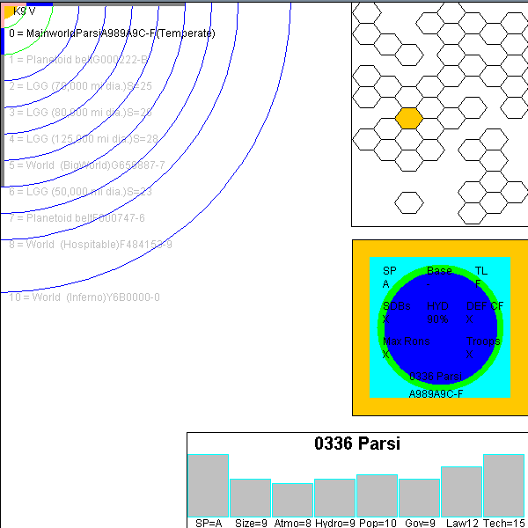

ORBIT PATHS
Red = Inner: Gress = Habitable: Blue = Outer
Pink Bar = 10D Blue Bar = 100 D Grey Bar = 1000D

5FW STYLE SYSTEM BOX
Outer Box = TAS zone
Inner Box = Atmosphere
Green Circle = Size
Blue Circle = Hydrographics


//=============================================================================
VLAND
https://wiki.travellerrpg.com/Vland_Sector

A Voskhod
https://wiki.travellerrpg.com/Voskhod_Subsector
https://wiki.travellerrpg.com/Voskhod_(world)
B Vhodan
https://wiki.travellerrpg.com/Vhodan_Subsector
https://wiki.travellerrpg.com/Vhodan_(world)
C Anarsi
https://wiki.travellerrpg.com/Anarsi_Subsector
https://wiki.travellerrpg.com/Anarsi_(world)
D Theton
https://wiki.travellerrpg.com/Theton_Subsector
https://wiki.travellerrpg.com/Theton_(world)

E Lalaki Kharir
https://wiki.travellerrpg.com/Lalaki_Kharir_Subsector
None
F Kagamira
https://wiki.travellerrpg.com/Kagamira_Subsector
https://wiki.travellerrpg.com/Kagamira_(world)
G Vland
https://wiki.travellerrpg.com/Vland_Subsector
https://wiki.travellerrpg.com/Vland_(world)
H Shiigus
https://wiki.travellerrpg.com/Shiigus_Subsector
https://wiki.travellerrpg.com/Shiigus_(world)

I Dusa
https://wiki.travellerrpg.com/Dusa_Subsector
None
J Akumid
https://wiki.travellerrpg.com/Akumid_Subsector
https://wiki.travellerrpg.com/Akumid_(world)
K Kasear
https://wiki.travellerrpg.com/Kasear_Subsector
https://wiki.travellerrpg.com/Kasear_(world)
L Anakod
https://wiki.travellerrpg.com/Anakod_Subsector
https://wiki.travellerrpg.com/Anakod_(world)

M Parsi
https://wiki.travellerrpg.com/Parsi_Subsector
https://wiki.travellerrpg.com/Parsi_(world)
N Daangiilu
https://wiki.travellerrpg.com/Daangiilu_Subsector
https://wiki.travellerrpg.com/Daangiilu_(world)
O Nulisud
https://wiki.travellerrpg.com/Nulisud_Subsector
https://wiki.travellerrpg.com/Nulisud_(world)
P Kakadan
https://wiki.travellerrpg.com/Kakadan_Subsector
https://wiki.travellerrpg.com/Kakadan_(world)

//=============================================================================

